Ready Reference Guides

See below

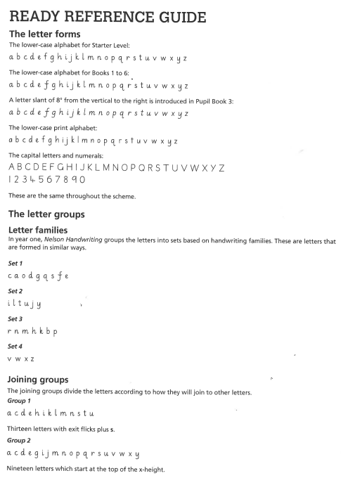
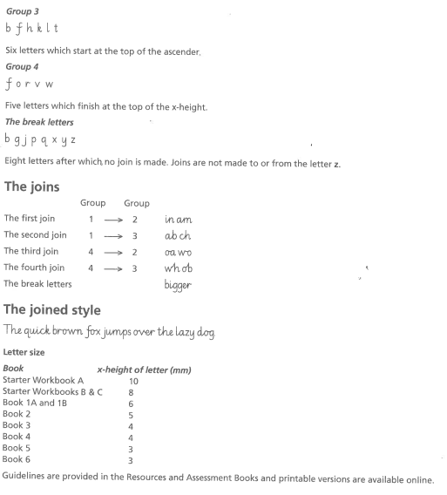

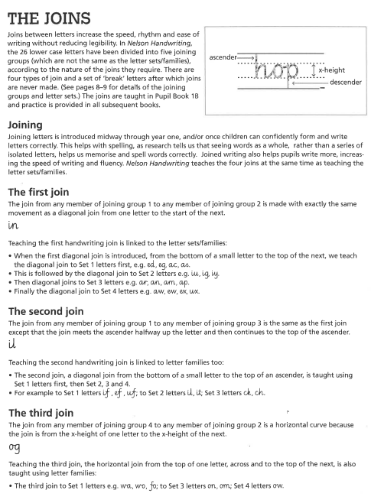

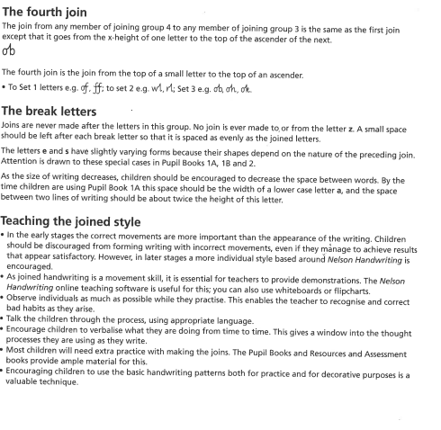

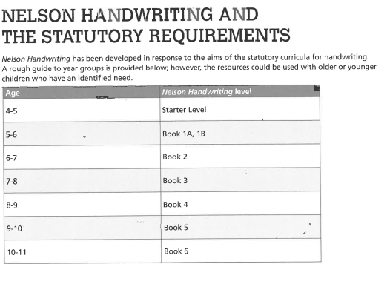

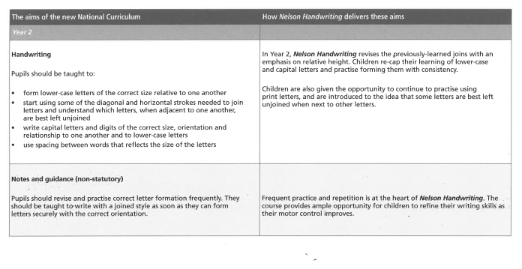
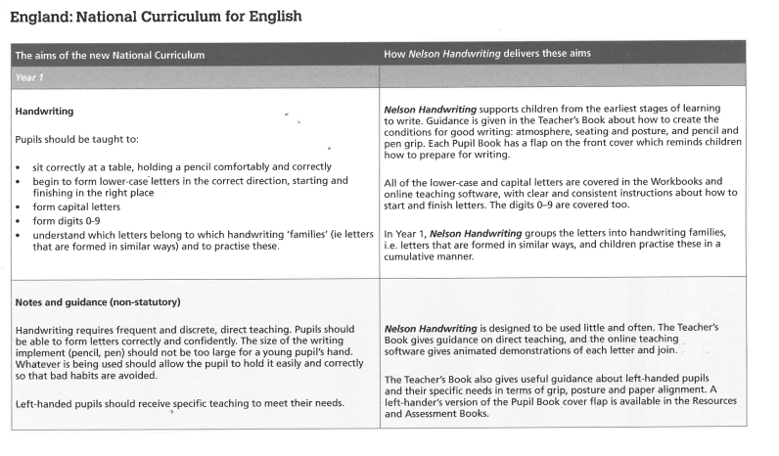
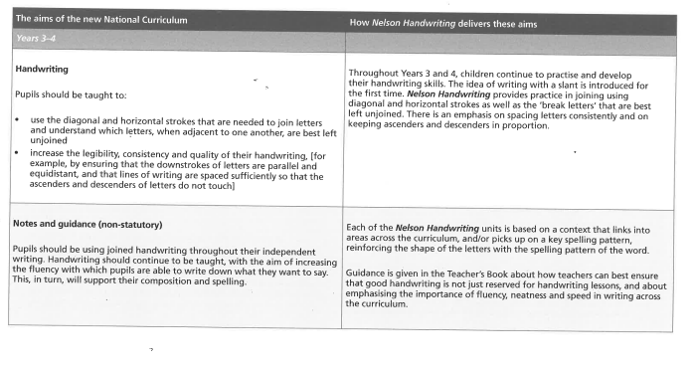
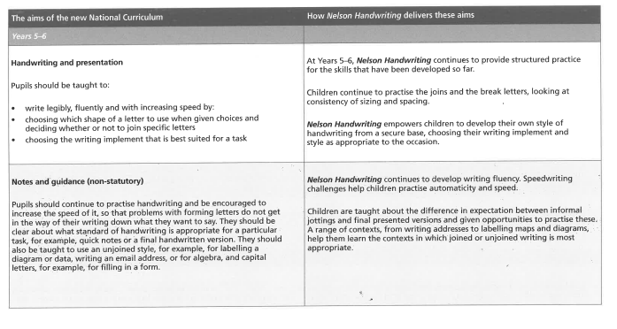
Pen license checklist
To earn a Pen Licence, all handwriting (not just in handwriting book) must show the following:
- All letters are correctly formed
- All “ x – height” letters are consistent in size
- All ascenders and descenders are correct height/ length
- All letters joined correctly
- Capital letters are larger than lower case letters
- Spaces between letters are the right size ( not too squashed or stretched
- Spaces between words are the right size ( not too small or big)
- Date and LO underlined with a ruler
- Work looks neat

